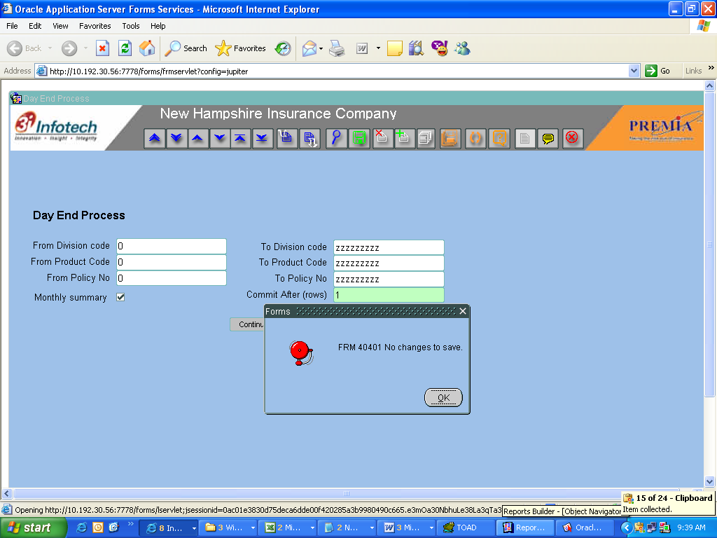

When button pressed code

:PGIT_SUMM_LOG_HDR.PSLH_CR_UID := :GLOBAL.M_LOGIN_USER_ID;
:PGIT_SUMM_LOG_HDR.PSLH_CR_DT := SYSDATE;

SELECT PGI_PSLH_SYS_ID.NEXTVAL INTO :PGIT_SUMM_LOG_HDR.PSLH_SYS_ID FROM DUAL;

-- inserting records to the header table

INSERT INTO PGIT_SUMM_LOG_HDR(
PSLH_SYS_ID,
PSLH_FR_DIV_CODE,
PSLH_TO_DIV_CODE,
PSLH_FR_PROD_CODE,
PSLH_TO_PROD_CODE,
PSLH_FR_POL_NO,
PSLH_TO_POL_NO,
PSLH_CR_UID,
PSLH_CR_DT,
PSLH_MONTHLY_UPD_YN,
PSLH_COMMIT_CNT
)
VALUES(
:PGIT_SUMM_LOG_HDR.PSLH_SYS_ID,
:PGIT_SUMM_LOG_HDR.PSLH_FR_DIV_CODE,
:PGIT_SUMM_LOG_HDR.PSLH_TO_DIV_CODE,
:PGIT_SUMM_LOG_HDR.PSLH_FR_PROD_CODE,
:PGIT_SUMM_LOG_HDR.PSLH_TO_PROD_CODE,
:PGIT_SUMM_LOG_HDR.PSLH_FR_POL_NO,
:PGIT_SUMM_LOG_HDR.PSLH_TO_POL_NO,
:PGIT_SUMM_LOG_HDR.PSLH_CR_UID,
:PGIT_SUMM_LOG_HDR.PSLH_CR_DT,
:PGIT_SUMM_LOG_HDR.PSLH_MONTHLY_UPD_YN,
:PGIT_SUMM_LOG_HDR.PSLH_COMMIT_CNT
);

standard.COMMIT;

PGIPK_SUMM_TABLE_UPD.MAIN_PROCESS(:PSLH_SYS_ID);

